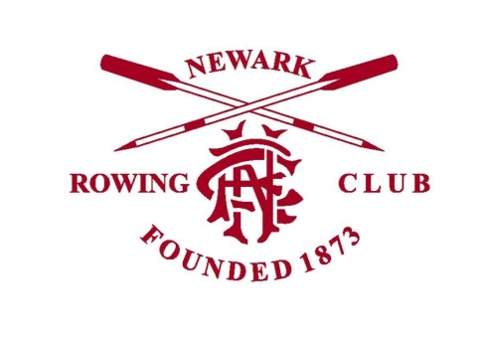

Junior Members at Newark Rowing Club
The policy regarding Junior members at Newark Rowing Club is as follows:

- A 'Junior' is anyone under 18 years old at the Club
- Junior members are not entitled to have a key card access to the Club, however their parent or carer may be issued with a keycard to enable them to accompany them onto the Rowing Club premises. Alternatively Junior members may arrive at a pre-arranged time for a coaching session where a responsible adult will be at the Club to meet them (see below).

- Following on from this, Junior members should not be unaccompanied on the Rowing Cub premises.

- Once on the premises Junior members should be 'handed over' to a responsible adult at the Club who is appropriately qualified (i.e. DBS cleared).
- Junior members should be met by their parent or carer to take them off the premises at the end of their session, or if appropriate and parents have made an alternative arrangement clear the Junior member may make their own way off the premises in line with this arrangement.

Coaches, Members, and Parents/ Carers are expected to enforce and respect this policy, there can be no exceptions.

Newark Rowing Club General Committee
April 2018

